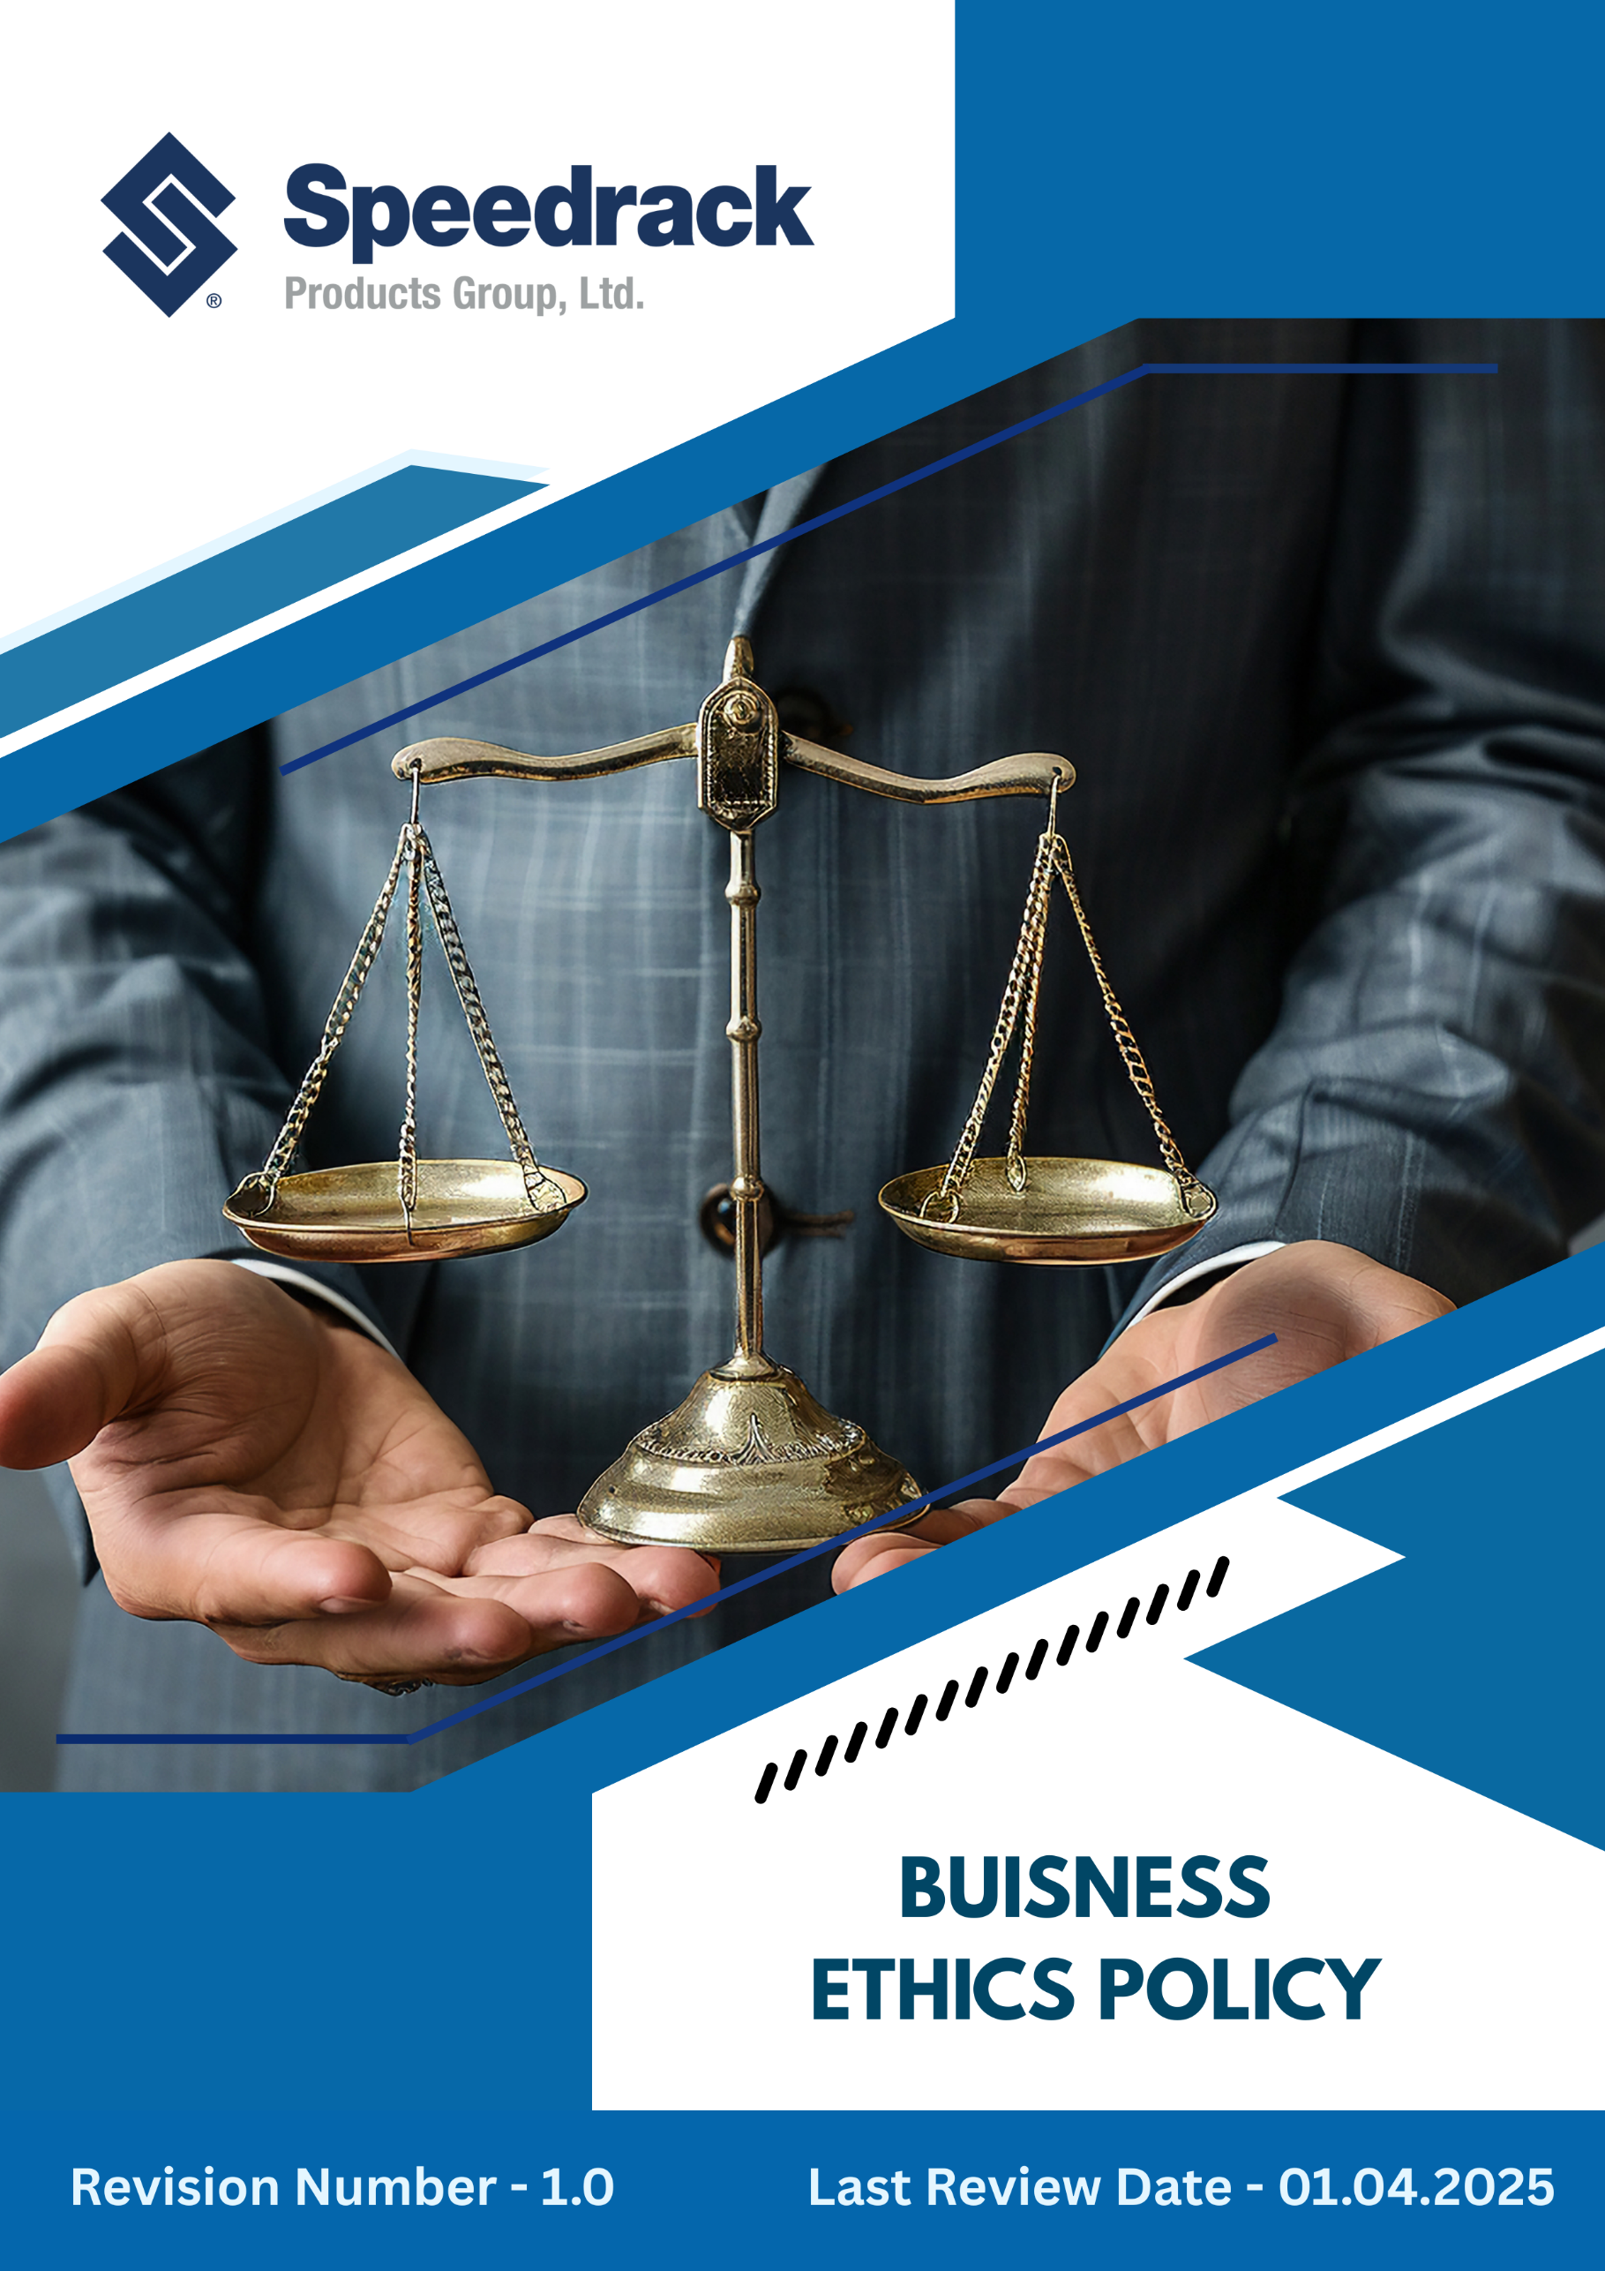
Contents
Introduction 3
Purpose 3
Scope 3
Our Focus Areas 4
Speedrack’s Approach towards the issues 4
Disciplinary Measures for Violations 8
Guidelines for Employees 9
Responsibility of this Policy 12
Reporting 13
Continuous Improvement 14
SDGs Covered by This Policy 14
Review Mechanism 14
Employee Acknowledgement Form 15

Introduction
Speedrack Products Group Ltd is committed to conducting all its operations with the highest standards of ethical conduct, integrity, and transparency. As a leading U.S. manufacturer of advanced storage and racking systems, we recognize that our business decisions from procurement and manufacturing to sales and distribution have an impact on our employees, customers, suppliers, and communities. Through this policy, we aim to embed ethical behavior, anti-corruption practices, and professional integrity into every stage of our business operations. Our goal is to ensure honest dealings, prevent misconduct, comply with laws and regulations, and maintain trust with all stakeholders. By fostering a culture of ethics and accountability, Speedrack seeks to protect its reputation, mitigate risks, and create long-term sustainable value.

Purpose
The purpose of this Policy is to:
- To define Speedrack’s overarching commitment to ethical business conduct and anti-corruption principles.
- To ensure all operations, products, and services comply with applicable laws, regulations, and industry standards.
- To prevent bribery, fraud, conflicts of interest, and unethical financial or operational practices.
- To promote transparency, accountability, and honesty in decision-making.
- To provide clear guidance to employees, contractors, and partners on ethical conduct and reporting mechanisms.
- To establish procedures for addressing violations and implementing corrective actions.
- To engage employees, suppliers, and partners in promoting a culture of integrity and responsible business practices.
- To provide a framework for monitoring, reviewing, and continuously improving business ethics performance.

Scope
This policy applies to all employees, contractors, partners, suppliers, customers, and individuals representing the Company. It covers all operations, corporate offices, manufacturing facilities, distribution sites, and any other premises under the Company’s management.
Sr. No | Unit Name | Address
1 | Manufacturing Site | 42 Cole St, Quincy, MI 49082
2 | Manufacturing Site | 3060 S Industrial Dr NW Walker, MI 49544
3 | Corporate Office | 3060 S Industrial Dr NW Walker, MI 49544

Our Focus Areas
- Integrity & Transparency: Conduct business honestly and communicate openly with stakeholders.
- Anti-Corruption & Bribery Prevention: Prohibit offering, receiving, or soliciting bribes, kickbacks, or improper incentives.
- Conflict of Interest Management: Disclose and avoid situations where personal interests could influence professional decisions.
- Financial & Operational Accuracy: Ensure all financial records, reporting, and business data are accurate, complete, and verifiable.
- Compliance with Laws & Standards: Follow all relevant anti-corruption, fraud, labor, and corporate governance regulations.
- Ethical Supplier & Partner Engagement: Partner only with entities that adhere to similar ethical and anti-corruption principles.
- Whistleblower Protection & Reporting: Encourage reporting of suspected unethical behavior without fear of retaliation.
- Training & Awareness: Educate all employees and relevant stakeholders on ethical standards, anti-corruption practices, and company policies.

Speedrack’s Approach towards the issues
This Business Ethics Policy defines the principles that guide our conduct, safeguard our reputation, and support a culture built on trust, respect, and accountability. The following targets have been set in alignment with Speedrack’s 2022 baseline performance data.
- Corruption & Bribery Prevention
- Maintaining zero tolerance for any form of bribery, kickbacks, or undue influence in business transactions is a top priority.
- Mandatory anti-corruption training will be delivered to all employees, contractors, and relevant partners.
- We plan to implement robust internal controls and due diligence procedures for all high-risk transactions, third-party engagements, and procurement activities
- We will integrate anti-corruption clauses in all supplier and partner agreements.
- We target 100% compliance with local anti-corruption laws, including the Prevention of Corruption Act, 1988.
- We strive to ensure 70% of employees and contractors complete annual anti-corruption training by 2030.
- We aim to maintain zero incidents of proven bribery or corruption annually.
- We will screen 100% of suppliers and partners for compliance with anti-corruption standards by 2030.
- Managing Conflict of Interest
- We are planning to ensure employees disclose any personal, financial, or family interests that could influence professional decisions.
- We aim to provide clear guidance to managers on evaluating and mitigating potential conflicts of interest.
- We aim to raise awareness through regular training sessions on conflict-of-interest scenarios, ethical decision-making, and reporting obligations across all departments.
- We are committed to ensuring that all conflicts of interest are fully reported and resolved, maintaining our track record of a transparent and clean compliance record.
- We strive to have 100% of employees trained on annual conflict of interest training by 2030.
- We plan to achieve 100% annual disclosure compliance from all employees in sensitive roles by 2030.
- We aim to resolve all conflict-of-interest cases identified through internal audits, targeting zero unresolved issues.

- Fraud Prevention
- Robust internal controls and approval procedures will be established to detect and prevent fraudulent activities.
- We aim to enhance our internal controls to effectively identify, report, and prevent fraud across all operations and financial processes.
- We aim to encourage a culture of reporting suspicious activities without fear of retaliation.
- We will implement structured employee training programs to enhance awareness, skills, and compliance with organizational policies, ethical standards, and regulatory requirements.
- Aim to cover 70% of employees through mandatory fraud prevention training by 2030.
- We strive to conduct annual internal audits covering 100% of high-risk business processes by 2030.
- We aim to achieve zero confirmed fraud incidents per year.
- Anti-Money Laundering
- Strict adherence to anti-money laundering (AML) regulations will be maintained, with due diligence applied to all financial transactions.
- We aim to screen and verify customers, partners, and financial transactions to prevent illicit activity.
- We are committed to providing regular training to employees in relevant departments on anti-money laundering (AML) regulations, risk indicators, and due diligence procedures to promote informed and vigilant decision-making.
- We ensure thorough Know Your Customer (KYC) and Know Your Business (KYB) checks are completed prior to establishing partnerships, signing contracts, or executing significant financial transactions.
- We maintain secure and organized records of all financial transactions and third-party engagements in compliance with AML regulations, supporting audit readiness and regulatory obligations.
- We target 100% compliance with the Prevention of Money Laundering Act (PMLA), 2002 and global AML standards.
- We strive to review 100% of financial transactions above regulatory thresholds for AML compliance by 2030.
- We will provide annual training for 100% finance and procurement personnel on AML regulations by 2030.
- We aim to have zero instances of non-compliance with AML reporting requirements.

- Responsible Information Management
- We are planning to maintain confidentiality, integrity, and security of sensitive company, employee, and customer information.
- We aim to ensure all critical systems and software are regularly updated and patched to reduce exposure to cybersecurity threats and vulnerabilities.
- The company is committed to delivering continuous cybersecurity awareness and data privacy training to all employees, fostering a culture of digital responsibility.
- We implement data encryption, multi-factor authentication, and secure access controls across all systems handling confidential or sensitive information.
- Regular internal audits and security assessments are conducted to identify risks, detect anomalies, and ensure compliance with data protection regulations, including the IT Act, 2000.
- Aim to Implement multi-factor authentication on all digital platforms by 2030.
- We strive to achieve 100% annual training of employees on data protection, phishing, and cybersecurity risks by 2030.
- Aim to Conduct two cybersecurity audits per year to proactively identify and mitigate risks.
- Ensure 100% encryption of all confidential employee and customer data by FY 2030.
- We strive to maintain a record of zero data breaches or cybersecurity incidents, continuing our track record of secure operations.
- Anti-Competitive Practices
- Fair competition will be promoted, and practices that undermine competition, such as price-fixing, market allocation, or collusion, are strictly prohibited.
- Policies and procedures will be strengthened to ensure compliance with all antitrust and competition laws.
- Employees and partners will receive training to recognize and avoid anti-competitive behavior.
- Zero incidents of anti-competitive conduct across all business operations annually.
- 100% of relevant employees trained on competition law compliance by 2026.
- Regular internal audits conducted to identify and mitigate potential anti-competitive risks.
- Whistleblower Protection & Reporting
- Confidential and accessible channels will be available for employees, contractors, and stakeholders to report unethical or illegal practices.
- Protection against retaliation or discrimination will be enforced for all whistleblowers.
- All reported concerns will be investigated promptly, fairly, and transparently.
- 100% of reported cases reviewed and resolved within a defined timeline annually.
- Zero cases of retaliation against whistleblowers.
- Annual awareness campaigns to ensure all employees understand reporting mechanisms.

Disciplinary Measures for Violations
Speedrack maintains a zero-tolerance stance toward unethical behavior and is committed to upholding the highest standards of integrity across all operations. Any breach of this Business Ethics Policy will be handled with seriousness and addressed through fair, responsible, and transparent procedures.
To ensure accountability and consistency, the following disciplinary measures may be applied based on the nature and severity of the violation:
- Investigation Process: All reported or suspected violations will undergo a thorough, impartial investigation conducted by the Human Resources and Compliance Teams.
- Warnings: Employees found to have violated the policy may receive a verbal or written warning, depending on the circumstances and impact of the violation.
- Suspension: For serious or complex cases, the employee may be temporarily suspended from duty pending the outcome of the investigation.
- Termination: Repeated misconduct or severe breaches of ethical, safety, or legal requirements may result in the termination of employment in line with company policies and employment laws.
- Legal Escalation: Violations involving fraud, corruption, bribery, theft, falsification of records, harassment, discrimination, or regulatory non-compliance may be escalated to appropriate legal or government authorities.
- Remedial Actions: Employees may be required to participate in corrective measures such as ethics training, counseling, or performance improvement programs to prevent recurrence.
- Supervisor Accountability: Managers or supervisors who knowingly ignore violations or fail to enforce this Policy may face disciplinary consequences.
- Supplier & Partner Compliance: Suppliers, contractors, and business partners are expected to uphold equivalent ethical and compliance standards. Contracts may be suspended or terminated if unethical or illegal practices are identified.
Zero-Tolerance Categories
Misconduct including bribery, corruption, harassment, discrimination, retaliation, intentional safety rule violations, or deliberate misuse/falsification of information will result in immediate dismissal and potential legal action.

Guidelines for Employees
Employees are expected to uphold the highest ethical standards in all aspects of their work. These guidelines provide practical direction to ensure integrity, professionalism, respect, and accountability across the organization.
1. Professional Conduct and Integrity
- Always behave honestly, respectfully, and professionally in all business interactions.
- Communicate clearly, accurately, and truthfully with clients, colleagues, suppliers, and stakeholders.
- Treat everyone with dignity and respect, even in difficult or stressful circumstances.
Example:
✅ If a client raises a concern about product delivery, provide accurate updates and suggest solutions.
❌ Hiding information, blaming others, or misleading stakeholders to avoid accountability is unacceptable.

2. Compliance with Laws and Company Policies
- Follow all applicable laws, regulations, and internal policies without exception.
- Participate in required training programs and follow established procedures.
- Report any suspected illegal or unethical activities immediately.
Example:
✅ If you become aware of non-compliance with safety procedures, report it immediately to HR or the Compliance Team.
❌ Ignoring unsafe practices or encouraging shortcuts to save time is a violation of this policy.

3. Conflict of Interest
- Avoid situations where personal interests could conflict with professional responsibilities.
- Do not accept gifts, payments, or favors that may influence work decisions.
- Disclose any relationships or circumstances that may affect objective decision-making.
Example:
✅ Inform HR if a supplier bidding for a project is a relative or close friend.
❌ Approving a contract with a vendor purely due to personal connections is unethical.

4. Confidentiality and Data Protection
- Protect all confidential business information, including employee, customer, and supplier data.
- Do not share internal documents, pricing, or trade information without authorization.
- Use company data and digital systems responsibly and securely.
Example:
✅ Store confidential files securely and use them only for work purposes.
❌ Sharing internal pricing data or customer lists with external parties is prohibited.

5. Fair Treatment, Inclusion & Respectful Workplace
- Support a workplace free from harassment, discrimination, retaliation, and bullying.
- Value diversity and promote equal opportunity.
- Speak up against inappropriate behavior and support colleagues with respect.
Example:
✅ Encourage team collaboration and show respect for different viewpoints.
❌ Using offensive language, making degrading comments, or excluding others is unacceptable.

6. Health, Safety & Environment
- Follow all safety guidelines and immediately report hazards or unsafe behavior.
- Do not engage in activities that put yourself or others at risk.
Example:
✅ Wear required protective gear and report damaged equipment.
❌ Ignoring safety procedures to complete tasks faster is strictly prohibited.

7. Anti-Bribery, Anti-Corruption & Fair Business Practices
- Do not offer, give, request, or accept bribes, kickbacks, or improper payments.
- Conduct business transparently and avoid fraudulent activities.
- Maintain accurate records and financial documentation.
Example:
✅ Politely refuse gifts of high value and report the offer to Compliance.
❌ Accepting money, gifts, or benefits in exchange for favourable decisions is a serious violation.

8. Use of Company Resources & Asset Protection
- Use company equipment, tools, technology, and financial resources responsibly and only for legitimate business purposes.
- Protect company property from theft, damage, misuse, or unauthorized use.
- Do not use company time or resources for personal gain or external work without approval.
- Ensure responsible usage of digital assets such as email, internet access, software, and communication tools.
Example:
✅ Use company vehicles, phones, and laptops only for approved work-related activities.
❌ Using company funds, assets, or tools for personal projects or outside business activities is strictly prohibited.

9. Accuracy of Records & Documentation
- Maintain complete, truthful, and accurate records in all reporting, documentation, and communication.
- Do not alter, manipulate, or falsify information for personal benefit or to influence results.
- Ensure transparency and accountability in financial, operational, and safety-related records.
Example:
✅ Report actual expenses, hours worked, and operational results without modification.
❌ Submitting false expense claims or altering project documentation to hide errors is unethical and may be illegal.

10. Responsible Communication & Social Media Conduct
- Communicate responsibly in both internal and external platforms, including social media.
- Do not post confidential information, harmful content, or negative statements about the company, colleagues, or customers.
- Only authorized personnel may speak on behalf of the company to media or public forums.
Example:
✅ Direct media inquiries to the Communications or HR department.
❌ Posting confidential company updates or criticizing co-workers publicly on social platforms is unacceptable.

11. Collaboration, Teamwork & Accountability
- Work cooperatively with team members and share responsibility for team results.
- Support colleagues and contribute positively to the work environment.
- Accept responsibility for mistakes and focus on corrective solutions.
Example:
✅ If an error impacts workflow, notify the team and help resolve the issue collaboratively.
❌ Blaming others or hiding mistakes to avoid consequences is a breach of trust.
12. Ethical Decision-Making
- Make decisions guided by honesty, fairness, and responsibility.
- Consider how actions may impact employees, customers, suppliers, and the broader community.
- Seek guidance from leadership or Compliance if unsure about the ethical implications of a decision.
Example:
✅ Ask HR for clarification if a request seems questionable or conflicts with ethical standards.
❌ Making decisions purely for personal benefit, regardless of risk or harm to others, is unacceptable.

Responsibility of this Policy
- Senior Leadership & Executive Management
- Provide clear direction, resources, and support necessary for effective implementation of this policy.
- Demonstrate ethical leadership through actions, decisions, and communication.
- Ensure compliance with all applicable laws, regulations, and internal standards.
- Promote a safe, respectful, transparent, and ethical workplace environment.
- Review and act on reports of violations or concerns, ensuring fair and confidential handling.
- Supervisors and Managers
- Serve as role models for ethical conduct and reinforce policy expectations within their teams.
- Ensure employees understand their responsibilities and receive appropriate guidance and training.
- Encourage open dialogue and support employees in raising concerns without fear of retaliation.
- Monitor daily adherence to ethical practices and report potential violations promptly.
- Take corrective actions when necessary to prevent recurrence of ethical issues.
- Employees
- Read, understand, and comply with the Business Ethics Policy and all related Company policies.
- Perform duties with honesty, professionalism, integrity, and respect for others.
- Report known or suspected violations, misconduct, conflicts of interest, or unethical behavior immediately.
- Seek clarification or support when faced with ethical dilemmas or uncertain situations.
- Protect confidential information, Company assets, and maintain a safe and respectful workplace.
- Chief Compliance Officer
- Review policy annually or as needed.
- Provide training, resources, and continuous education related to ethical conduct and policy requirements.
- Facilitate reporting channels and ensure concerns are investigated promptly and impartially.
- Maintain confidentiality and ensure protection from retaliation for individuals reporting in good faith.
- Track policy compliance, monitor trends, and recommend improvements to enhance ethical practices.

Reporting
- Speedrack maintains systematic monitoring of ethical conduct through periodic reviews, compliance dashboards, incident reporting systems, and behavior risk assessments.
- The People & Compliance Teams prepare an annual Ethics & Integrity Performance Report, summarizing elements such as misconduct case resolution timelines, training participation, conflict-of-interest disclosures, whistleblowing statistics, and cultural engagement outcomes.
- Progress, challenges, and improvement measures are presented to Executive Management and the Board to support transparent decision-making and reinforce accountability.
- Speedrack provides accessible, confidential, and anonymous reporting mechanisms that enable employees and partners to raise ethical concerns safely and without fear of retaliation.

Continuous Improvement
Speedrack Products Group Ltd is committed to continuously advancing ethical behavior and integrity across the organization. Performance is regularly evaluated through internal audits, stakeholder feedback, culture assessments, and external reviews. The company invests in training, digital compliance tools, awareness programs, and leadership development to strengthen ethical decision-making. We collaborates with employees, representatives, and supply chain partners to identify improvement opportunities, prevent misconduct, and uphold integrity. Corrective and preventive actions are taken promptly to address violations, close compliance gaps, and maintain trust and transparency.

SDGs Covered by This Policy
This Environmental Policy supports the following United Nations Sustainable Development Goals (SDGs):
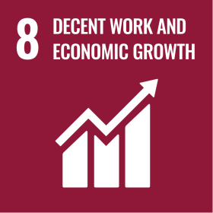 | 

Review Mechanism
Chief Compliance Officer conducts an annual review or as needed of this Ethics Policy to assess compliance performance, identify improvement needs, and ensure alignment with evolving legal, ethical, and industry expectations. Updates or enhancements may be implemented based on review findings, governance priorities, or global regulatory changes. Any modifications or significant updates are communicated to employees, business partners, and relevant stakeholders to maintain clarity, transparency, and organizational alignment.
Effective Date: 01.12.2024
Last Review Date: 01.04.2025 Rev. No. 1.0
Next Review Date: 01.04.2026

Employee Acknowledgement Form
I acknowledge that I have received, read, and understood Speedrack Products Group Ltd.’s Business Ethics Policy.
I understand my responsibility to uphold ethical conduct, integrity, transparency, and respect in all professional interactions, and to report any violations promptly and responsibly.
I recognize that following this policy is a mandatory requirement of employment, and failure to comply may result in appropriate disciplinary action.
By signing below, I agree to support and comply with this policy.

Employee Name: ___________________________________
Department: ________________________________________
Designation: ________________________________________
Signature: ___________________________________________
Date: ______________________________________________

